Name ___________________________________________ Hour ___________
AP Macroeconomics Unit 6 Practice Test – Economic Growth & International Trade

_____ 1 | Comparing the short-run and long-run Phillips curve suggests that:
 | A) | there is both a short-run and long-run tradeoff between inflation and unemployment.
 | B) | there is neither a short-run nor a long-run tradeoff between inflation and unemployment.
 | C) | there is a short-run but not a long-run tradeoff between inflation and unemployment.
 | D) | there is a long-run but not a short-run tradeoff between inflation and unemployment.

_____ 2 | 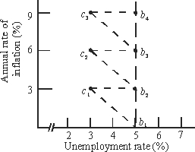  Refer to the diagram. Assume the economy is initially at point b₂. In the short run, an increase in aggregate demand will initially move the economy from point b₂ to point:
 | A) | A) b₁. B) b₃. C) C₁. D) C₂.

_____ 3 | 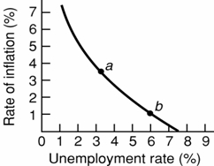  Refer to the diagram. Stagflation would be represented by:
 | A) | a movement along the curve from point a to point b.
 | B) | a movement along the curve from point b to point a.
 | C) | a rightward shift of the curve.
 | D) | a leftward shift of the curve.

_____ 4 |  | A shift outward of the production possibilities curve would be equivalent to a shift
 | A) | upward in aggregate demand
 | B) | downward in aggregate demand
 | C) | rightward in long-run aggregate supply
 | D) | leftward in long-run aggregate supply

_____ 5 | Use the following graph to answer question.  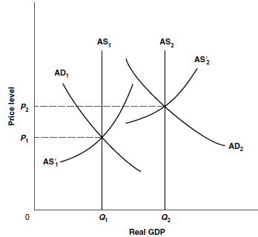  Which combination would best explain a shift in the price level from P₁ to P₂ and an increase in real domestic output from Q₁ to Q₂?
 | A) | an increase in the long-run aggregate supply (AS₁ to AS₂) and in short-run aggregate supply (AS'₁ to AS'₂).
 | B) | an increase in aggregate demand (AD₁ to AD₂) and a decrease in long-run aggregate supply (AS₂ to AS₁).
 | C) | an increase in the long-run aggregate supply (AS₁ to AS₂), an increase in aggregate demand (AD₁ to AD₂), and an increase in short-run aggregate supply (AS'₁ to AS'₂).
 | D) | a decrease in the long-run aggregate supply (AS₂ to AS₁), a decrease in aggregate demand (AD₂ to AD₁), and a decrease in short-run aggregate supply (AS'₂ to AS'₁).

_____ 6 | A cause of both higher rates of inflation and higher rates of unemployment would be
 | A) | an increase in aggregate demand
 | B) | an increase in aggregate supply
 | C) | a decrease in aggregate demand
 | D) | a decrease in aggregate supply

_____ 7 | Total real output can be determined by:
 | A) | multiplying total hours of work times labor productivity.
 | B) | multiplying total wages paid times output per hour of work.
 | C) | dividing total wages paid by labor productivity.
 | D) | dividing total hours of work by labor productivity.

_____ 8 | The factor accounting for the largest increase in the productivity of labor in the United States has been
A) | economies of scale
B) | technological advance
C) | the quantity of capital
D) | the education and training of workers

_____ 9 | A supply factor in economic growth would be
 | A) | an increase in the efficient use of resources
 | B) | a decline in the rate of resource depletion
 | C) | an improvement in the quality of labor
 | D) | an increase in consumption spending

_____ 10 | Which is a demand factor in economic growth?
 | A) | an increase in the purchasing power of the economy
 | B) | an increase in the economy's stock of capital goods
 | C) | more natural resources
 | D) | technological progress

_____ 11 | If a U.S. citizen could buy £25,000 for $100,000, the rate of exchange for the pound would be
 | A) | $40
 | B) | $25
 | C) | $4
 | D) | $.25

_____ 12 | Consider the following hypothetical exchange rates: $1 = .50 British pounds; 1 Chinese yuan = $.10. We can conclude that 1 pound trades for:
 | A) | 10 yuan.
 | B) | 5 yuan.
 | C) | 1 yuan.
 | D) | 20 yuan.

_____ 13 | 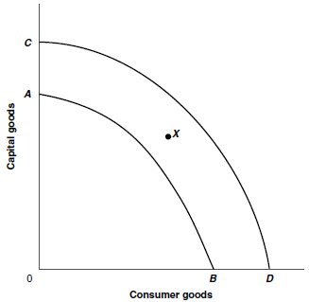  If the production possibilities curve of an economy shifts from AB to CD, it is most likely the result of what factor affecting economic growth?
 | A) | a supply factor
 | B) | a demand factor
 | C) | an efficiency factor
 | D) | an allocation factor

_____ 14 | If the production possibilities curve for an economy is at CD but the economy is operating at point X, the reasons are most likely
 | A) | supply and environmental factors
 | B) | Demand and efficiency factors
 | C) | labor inputs and labor productivity
 | D) | technological progress

_____ 15 | A nation's balance on the current account is equal to its exports less its imports of
 | A) | goods and services
 | B) | goods and services, plus U.S. purchases of assets abroad
 | C) | goods and services, plus net investment income and net transfers
 | D) | goods and services, minus foreign purchases of assets in the United States

_____ 16 | The net investment income of the United States in its international balance of payments is the
 | A) | interest income it receives from foreign residents
 | B) | value of dividends it receives from foreign residents
 | C) | excess of interest and dividends it receives from foreign residents over what it paid to them
 | D) | excess of public and private transfer payments it receives from foreign residents over what it paid to them

_____ 17 | 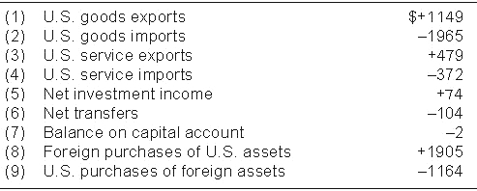  The balance on the current account was a
 | A) | surplus of $739 billion
 | B) | deficit of $739 billion
 | C) | surplus of $816 billion
 | D) | deficit of $816 billion

_____ 18 | The balance on the financial account was a
 | A) | deficit of $372 billion
 | B) | surplus of $479 billion
 | C) | deficit of $739 billion
 | D) | surplus of $741 billion

_____ 19 | If a nation's balance on current account is positive and it has neither a deficit nor surplus in its overall balance of payments:
 | A) | its imports exceed its exports.
 | B) | foreign purchases of its assets exceed its purchases of assets abroad.
 | C) | it has a trade deficit.
 | D) | it has a capital and financial account deficit.

_____ 20 | Assuming exchange rates are flexible, which of the following should increase the dollar price of the Swedish-krona?
 | A) | a rate of inflation greater in Sweden than in the United States
 | B) | real interest rate increases greater in Sweden than in the United States
 | C) | national income increases greater in Sweden than in the United States
 | D) | the increased preference of Swedish citizens for U.S. automobiles over Swedish automobiles

_____ 21 | Use the following diagram to answer the next question:  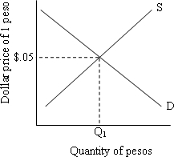  Refer to the diagram. At the equilibrium exchange rate:
 | A) | $1 will buy 20 pesos.
 | B) | $1 will buy 5 pesos.
 | C) | 95 pesos will buy one dollar.
 | D) | 5 pesos will buy one dollar.

_____ 22 | Refer to the diagram. Suppose the U.S. increases its imports from Mexico. All else equal, this would:
 | A) | shift the demand curve to the left, causing the dollar to depreciate.
 | B) | shift the demand curve to the right, causing the dollar to depreciate.
 | C) | shift the supply curve to the right, causing the dollar to appreciate.
 | D) | shift the supply curve to the left, causing the peso to appreciate.

_____ 23 | Answer question using the graph below.  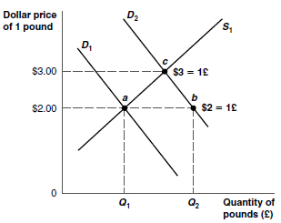  If D₁moves to D₂, the U.S. dollar has
 | A) | appreciated, and the British pound has depreciated
 | B) | appreciated, and the British pound has appreciated
 | C) | depreciated, and the British pound has depreciated
 | D) | depreciated, and the British pound has appreciated

_____ 24 | If D₁ moves to D₂, but the British government seeks to keep the exchange rate at $2 = 1£, then it can do so through policies that
 | A) | increase the supply of pounds and decrease the demand for pounds
 | B) | decrease the supply of pounds and increase the demand for pounds
 | C) | increase the supply of pounds and increase the demand for pounds
 | D) | decrease the supply of pounds and decrease the demand for pounds

_____ 25 | What would be the effect on U.S. imports and exports when the United States experiences strong economic growth but its major trading partners experience sluggish economic growth?
 | A) | U.S. imports will increase more than U.S. exports
 | B) | U.S. exports will increase more than U.S. imports
 | C) | U.S. imports will decrease but U.S. exports will increase
 | D) | there will be no effect on U.S. imports and exports

Name ___________________________________________ Hour ___________
AP Macroeconomics Unit 6 Practice Test – Economic Growth & International Trade
_________ 1

_________ 2

_________ 3

_________ 4

_________ 5

_________ 6

_________ 7

_________ 8

_________ 9

_________ 10

_________ 11

_________ 12

_________ 13

_________ 14

_________ 15

_________ 16

_________ 17

_________ 18

_________ 19

_________ 20

_________ 21

_________ 22

_________ 23

_________ 24

_________ 25

